License Agreement and Limited Warranty
By accepting and using this software the user agrees: That this is a legal agreement between you (either an individual or entity), the end user, and Warren Design Vision™. If you do not agree to the terms of this Agreement, promptly delete the software and accompanying folders.

Warren Design Vision™ (WDV) Software License
1. LICENSE GRANT: Your payment for this copy of the software authorizes you to use the specified version of the Warren Design Vision™ software accompanying this document, hereafter referred to as the Software.
2. COPYRIGHT: The Software accompanying this document is owned by Warren Design Vision™ and is protected by United States copyright laws and international treaty provisions. The software is like any other copyrighted material except that you may make any number of copies of the Software for personal working, backup and archival purposes ONLY.
3. OTHER RESTRICTIONS: You may not rent or lease the Software, but you may transfer your rights under this agreement on a permanent basis provided you transfer this license agreement and the Software. You may not reverse engineer, decompile, or disassemble the Software.

Limited Warranty
1. LIMITATIONS: Warren Design Vision™ warrants that a) the Software will perform the calculations for which it was designed for a period of ninety (90) days from the date of receipt. Any implied warranties on the Software is limited to ninety (90) days.
2. REMEDY: Warren Design Vision™'s entire liability and your exclusive remedy shall be, at Warren Design Vision™'s option, either:
(a) return of the price paid or
(b) repair or replacement of the Software that does not meet the Limited Warranty above.
3. DISCLAIMER: Warren Design Vision™ disclaims all other warranties, either express or implied, including but not limited to implied warranties of merchantability and fitness for a particular purpose, with respect to the Software. This limited warranty gives you specific legal rights which may vary from state to state.
4. CONSEQUENTIAL DAMAGES: In no event shall Warren Design Vision™ or its suppliers be liable for any damages whatsoever (including, without limitation, damages for loss of business profits, business interruption, loss of business information, or other pecuniary loss) arising out of the use or inability to use this product, even if the vendor has been advised of the possibility of such damages. Because some states do not allow the exclusion or limitation of liability for consequential and incidental damages, the above limitation may not apply to you. This product is provided "as is" with no warrant of merchantiblity or fitness for any purpose expressed or implied. The user assumes all liability for damages resulting from the use or misuse of this product. Warren Design Vision's liability is limited to replacement of this software if it is found to be defective.

U.S. Government Restricted Rights
This Software and documentation are provided with RESTRICTED RIGHTS. Use, duplication, or disclosure by the Government is subject to restrictions as set forth in subparagraph (c)(1)(ii) of the Rights in Technical Data and Computer Software clause at DFARS 252.227-7013 or subparagraphs (c)(1) and (2) of the Commercial Computer Software-Restricted Rights at 48 CFR 52.227-19, as applicable. Contractor/manufacturer is Warren Design Vision™ available via http://www.wdv.com. This agreement is governed by the laws of the State of California.

BeamCALC™ Prerequisites

To use BeamCALC™ you will need:

a) Microsoft Excel™
OR
b) Microsoft Office™ XP
earlier versions may work, but you are on your own.

HINTS:

- Avoid working in your original copy! Make a FRESH copy of BeamCALC™ each time you start a new analysis.

It will save you repeating this procedure. Now you are ready to begin! Here is a table of worksheets:

 Utility Sheets

Registration
Help
Limits
Units
Materials
Sections

S imply Supported Beam Sheets
Concentrated Moment
Concentrated Force
Linearly Varying Force, A
Linear Force, B
Superposition

C antilevered Beam Sheets
Concentrated Moment
Concentrated Force
Linearly Varying Force, A
Linear Force, B
Superposition

Starting Up

Start up the file BeamCALC™ Working Copy:

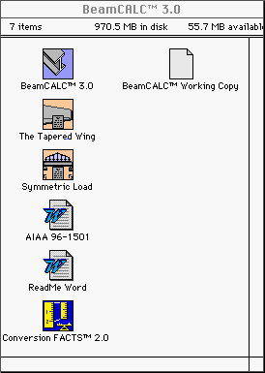

Getting Around

You will observe a row of tabs along the bottom of the window. These tabs control navigation to the various sheets used for your analysis:

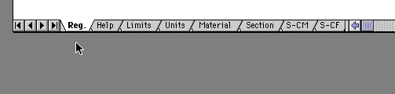

To execute trade studies change sheets and enter new parameters. For more information most sheets scroll down and over.

• Notice •
It is assumed that you have registered your copy of BeamCALC™. This is necessary in order for the program to work properly.

 Help

The Help section is available via the tab.

• Notice •
You may obtain help at any time by clicking on .
Help is also available online using the button..

 Limitations

Life is full of limitations:
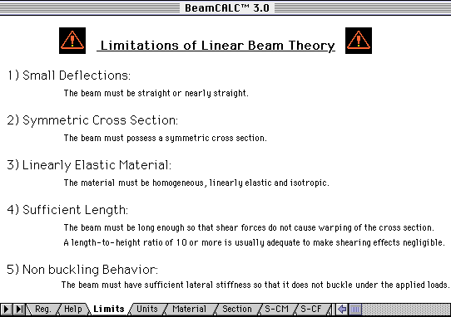

BeamCALC™ is no exception. Before beginning any analysis, review all the limitations in the sheet to insure that this tool is appropriate for your problem. Don’t be shy about calling an expert!
 Units

Click on the tab labeled . Enter a system of units in the highlighted box. Type "US" for domestic units or "SI" for metric units. This choice affects all the sheets you use in your analysis.

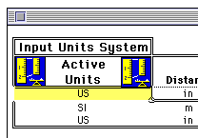

Entering key parameters in highlighted boxes is a repeating theme in BeamCALC™.

• Notice •
An abbreviated conversion factors package is contained in the Units sheet. It is there for your convenience in converting to and from common units of length, mass and force.
Scratch calculations that you make here will not affect calculations in other sheets.

 Example Problem

Consider a wing spar for an unmanned experimental reconnaissance drone with a wing span of 16 feet.

The spar, a reinforcing structure that runs along the span of the wing is to be made of 4" O.D. cylindrical aluminum tubing of constant cross section. The wing chord is 3.0 feet at the root and 2.0 feet at the tip. Initial sizing studies suggest that the weight of the aircraft at roughly 200 pounds. A project goal is to be capable of tolerating a 6 G's positive and negative. We wish to know, to first order, the approximate weight of the spar.

Solution: Material Selection 

We are ready to specify a material. Do this by clicking the tab. Since the alloy designation was not stated in the problem, we make the conservative choice of 6061-T6. Copy and paste, or type, the material name into the highlighted box:

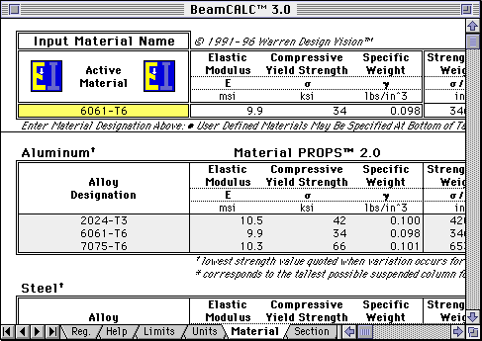

• Notice •
Variation in material properties is often difficult to control. Make sure the material name you choose reflects the properties of the material lot you are using.
 Solution: Cross Section

Having finished specifying the Active Material, it is time specify a cross section. Click the tab:
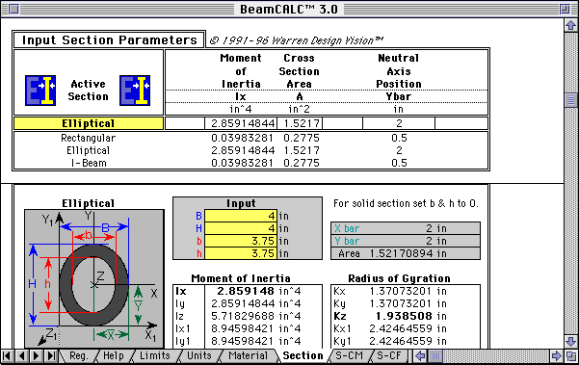

The problem stated that the beam was to be made of cylindrical tubing 4" in outer diameter. The inner dimension was not constrained, so we arbitrarily choose a quarter of an inch wall thickness. We can use this inner dimension as a degree of freedom to find the lightest possible beam.
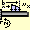 Solution: Beam and Load Combination

We will model our spar as a cantilevered beam and will apply a linearly varying distributed force. We note that there are two C-LF's, labeled A and B. We choose C-LF,A:

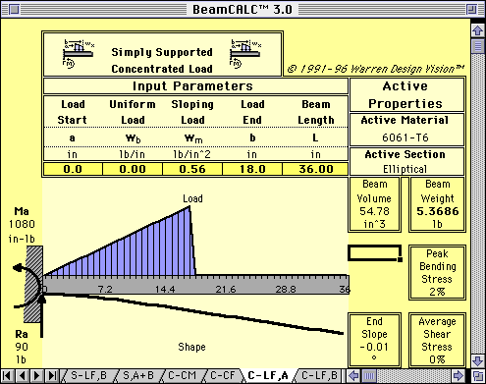

• Notice •
Until the proper values for the problem at hand are entered into the highlighted boxes the graphs and numbers are nonsense.
Solution: Load Specification

We know from the problem description that the load is over the entire wing, which is 16 feet long. But we are modeling only half a wing and we are working in inches:
so we enter: a = 0 inches, b = 8*12 inches and L = b into
the highlighted boxes.

We must also compute the sloping and uniform portions of the load. These are:

$$w(x)=w_{m}x+w_{b}=\frac{2W}{L^{2}}\left(\frac{t−r}{t+r}\right)x+\frac{2W}{L}\left(\frac{r}{r+t}\right)$$
where:
L = half span W = weight
r = root chord t = tip chord
w_{m} = varying load w_{b} = constant load

For our example this is:

$$w(x)=−\frac{5}{\text{2304}}\left[\frac{\text{lbs}}{{\text{in}}^{2}}\right]x+\frac{5}{4}\left[\frac{\text{lbs}}{\text{in}}\right]$$

We have left two things out of this expression that are really important, the first is the 6 G load multiplier and the second is a safety factor that would account for material variation, manufacturing defects, etc.. We will use a safety factor of 1.5.

The correct load expression reads:

$$w(x)=−\frac{\text{45}}{\text{2304}}\left[\frac{\text{lbs}}{{\text{in}}^{2}}\right]x+\frac{\text{45}}{4}\left[\frac{\text{lbs}}{\text{in}}\right]$$
BeamCALC™ Solution: Beam Weight

Substituting this information into the C-LF,A sheet causes the following analysis to be performed:

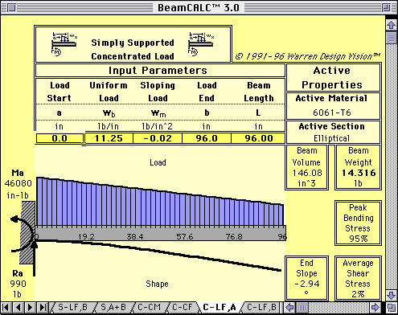

This is a reasonable graphic for the load. The beam is nearly at peak bending stress, so we stop now and report a first order spar weight of 29 pounds, which is what we set out to find.
BeamCALC™ Solution: Shear & Bending

Scrolling further down in the same sheet we can observe the resulting shear and bending moment diagrams:

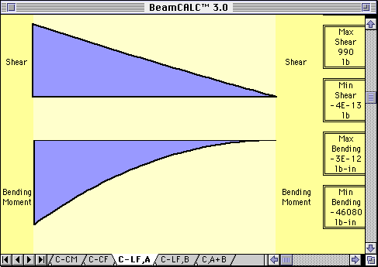

Scrolling to the right displays the numerical values used to produce the graphs shown.

Self Test

1) Why did we report 29 pounds as the spar weight instead of 14.316 pounds?

2) Does the reaction of 990 pounds correspond with our expectations?

3) Why is the wing bowed down instead of up?

4) How could we reduce the weight of the spar further without violating the assumptions we started with?

5) Why did the load coefficients increase by a factor of 9 when we included the G load and safety factor?

If you answered these questions correctly, you are now ready to try an example of your own.

 Answers

1) We analyzed only half the spar, the whole spar weighs twice the result here. Since this was a first order analysis we only reported two significant figures of weight.

2) Considering only the constant part, the load, to first order, must be approximately:
11.25 lb/in * 96 in = 1080 lbs
990 lbs was within reason considering the slope of the load curve was negative. These kind of 'sanity checks' are important to do on every result of every structural problem.

3) The spar is bowed down because we applied the load from the top. The wing neither knows nor cares whether it is upside down or rightside up in this example.

4) The spar is currently at 95% bending stress, and technically we want to take it to 99.999% by increasing the inner diameter since we have already included safety margins and G loads. This will result in some decrease in weight. Changing alloy or material family could also decrease weight but would have required changing our conservative assumptions about the problem.

5) Because 6 G's times a safety factor of 1.5 is 9.

More On Material Selection

Dragging the vertical scroll bar --> 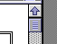
downward enables additional materials to be viewed.
There are a number of common engineering metals, plastics and other materials compiled from a variety of sources:

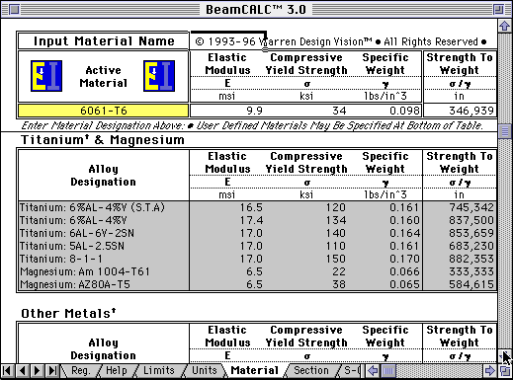

Advanced Uses

Advanced users who are intimately familiar with the limitations of linear beam theory may select anisotropic materials for analysis of wood or composite beams.

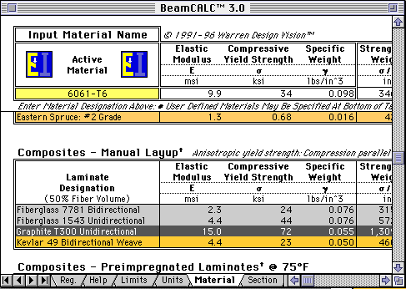

• Notice •
Any beam designed using this program should be subjected to a rigorous quality control and testing program.

Advanced Uses

If you are unable to find a listed material which meets your specifications, create a custom material entry:

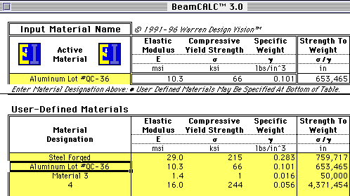

Enter your custom name and properties in the highlighted user-defined material table. Then enter your custom name as the Active Material.

"In the absence of knowledge,
proceed with an abundance of caution."

•

Appendix A: The Symmetric Distributed Load Problem

Problem: A beam is subjected to a symmetric distributed load along its span:

Determine the spanwise load constants w_{m}, w_{b}, w_{m}’, and w_{b}’, in the distributed load equations:

$$w(x)=w_{m}x+w_{b}$$

and
$$w^{'}(x)=w_{m}^{'}x+w_{b}^{'}$$

(primes refer to the second load, not derivative quantities.)
in terms of:
w_{l}: distributed load value at left and right ends.
w_{r}: distributed load value at peak.
a, b, L: from diagram

Solution:
$$\begin{aligned}w(x)=\frac{\text{rise}}{\text{run}}x+w_{b} \\ =\frac{w_{r}−w_{l}}{b−a}x+w_{l} \\ w_{m}=\frac{w_{r}−w_{l}}{b−a} \\ w_{b}=w_{l}=\text{deadLoad}=\frac{b−a}{L}\text{selfWeight} \\ − \\ w^{'}(x)\text{=-}w_{m}x+\left(w_{l}+w_{m}b\right) \\ w_{m}^{'}\text{=-}w_{m} \\ w_{b}^{'}=w_{l}+w_{m}b \\ \end{aligned}$$
Appendix B: he Linearly Tapered Wing Problem

Problem: A linearly tapered wing is subjected to a uniformly distributed load along its entire planform surface.

Determine the spanwise load constants and in the distributed load equation:

in terms of the wing span, root chord, rip chord and applied load.

Solution:
Let
L = half span of wing from root to tip.
r = root chord
t = tip chord
Ac = region of constant load per unit length
Av = region of varying load per unit length
Aw = Ac + Av = total wing area
Wc = load in Ac
Wv = load in Av
W = total applied load
wc(x) = load as a function of x in constant region.
wv(x) = load as a function of x in varying region.
w(x) = wc(x) + wv(x) = total spanwise load
wm = slope of spanwise load function
wb = intercept of spanwise load function.

We will solve the problem in two parts. First we will find the portion of the load that does not vary with span, this will be called wc(x) where the subscript 'c' stands for constant. Then we will find the varying part of the load, called wv(x) where 'v' stands for variable. The following diagram will help us divide the problem into these two parts:

First :

Proof:

Next :

Proof:

Now we must formulate the load distribution in two parts, for the constant region and the varying region. We'll start with the constant case. We know that its graph looks like:

But all that we can establish from this is that:
However, we do know that this portion of the distributed load must sum to , which gives us a basis for finding the value of the unknown k:

Having solved the problem for the constant region we can now turn our attention to the varying one. We know that the linear taper in the wing gives rise to a linearly varying load whose graph is as follows:

The equation of this load function looks like this:

Again we are in the position of having to deduce the value of an unknown constant, in this case . To do this we again refer to the fact that the total area of the load curve must equal :

To solve the original problem, that is finding the slope and intercept of the combined load we add the two load distribution functions:

but we want to factor things like so:

where:

and:
which when boiled down and substituted gives:

