A Blazing Fast Introduction™ to
Software Defined Radio (SDR)

Chapter 1: Background

By L. Van Warren MS CS, AE - AE5CC

Published By:

© 2007-2008 L. Van Warren • All Rights Reserved

No part of this book may be reproduced or copied in any form without written permission from the publisher. Purchasers of the electronic edition of this book are permitted to make one color print of the book from the PDF version of the document.

Library of Congress Catalog Card Number: 2004115400

To my Dad, who introduced me to a world through radio.
Table of Contents
In The Beginning… Crystal Radio 3
Figure 1: Earth Footprints of Celestial Radio Sources 3
Introduction 3
Figure 2: Mix and Match Postcards for Chapter 1 4
Figure 3: Crystal Radio PostCardKit™ 5
Figure 4: Visualization of Radio Spectrum 5
The Crystal Radio PostCardKit™ 5
Putting Up the Litz 6
Formula: Resonant Frequency 6
Figure 5: Ideal Reception 6
Using the Crystal Radio 7
Figure 6 – Keeping a log enables discovery. 7
Basic Parts 7
Example 0: Crystal Radio Schematic and Values 8
Tip - Use dB to compare the power of radio signals. 8
Formula: Ohm’s Law 9
Formula: Power 9
Formula: Series Equivalent Resistance 9
Formula: Parallel Equivalent Resistance 9
Circuit 1: Classic Voltage Divider Solved in Tidy TINA. 10
Figure 7: No room for color codes on surface mount resistors! 10
Notes on Resistors. 10
Inductors 11
Circuit 2: Inductor Transient DC Response 11
Circuit 3: Inductive AC Response 12
Frequency Response: What Happens When Inductance and Resistance Change? 13
Circuit 4: One milliHenry Inductor Frequency Response 13
Circuit 5: One microHenry Inductor Frequency Response 14
Circuit 6: Inductive Frequency Response – Increased Series Resistance 15
Inductor Calculations 16
Formula: Series Equivalent Inductance 16
Formula: Parallel Equivalent Inductance 16
Formula: Inductive Reactance 16
Formula: Inductive Time Constant 16
Circuit 7: Capacitor Voltage and Current Vs. Time, Transient DC Response 17
Table 1: Unit Prefixes, Abbreviations and Multipliers 17
Circuit 8: Capacitive AC Response 18
Frequency Response: What Happens When Capacitance and Resistance Change? 19
Circuit 9: 100 uF Capacitor Frequency Response 19
Circuit 10: 1 uF Capacitor Frequency Response 20
Circuit 11: Capacitive Frequency Response – Increased Series Resistance 21
Capacitor Calculations 22
Formula: Parallel Equivalent Capacitance 22
Formula: Parallel Equivalent Inductance 22
Formula: Capacitive Time Constant 22
Formula: Capacitive Reactance 22
Summary – Capacitance and Inductance: 23
Figure 8: Side-By-Side Comparison - Capacitance and Inductance 23
RLC Behavior – Parallel Case 24
Circuit 12: RLC Circuit – Parallel LC 24
Figure 9: RLC Circuit – Parallel LC – Voltage Gain 24
Figure 10: RLC Circuit – Parallel LC – Current Gain 25
Figure 11: RLC Circuit – Parallel LC – Power Gain 25
RLC Behavior – Series Case 26
Circuit 13: RLC Circuit – Series LC 26
Figure 12: RLC Circuit – Series LC – Voltage Gain 26
Figure 13: RLC Circuit – Series LC – Current Gain 27
Figure 14: RLC Circuit – Series LC – Power Gain 27
Diodes 28
Circuit 14: Diode Transient DC Response – Forward Current 28
Circuit 14: Diode Transient DC Response – Reverse Current 29
Circuit 15: Diode AC Circuit 29
Figure 15: Diode 60 Hz Frequency Response 30
Figure 16: Diode 44 kHz Frequency Response 30
Figure 17: 1N1183 Diode 1 MHz Frequency Response 31
Figure 18: 1N4150 Diode 1 MHz Frequency Response 31
Diode Calculations 32
Formula: Series Equivalent Inductance 32
Formula: Series Equivalent Inductance 32
It the first case it is necessary connect a high value resistor across eacg diode to minimize transients and equalize slight differences in the characteristics of the diode. One rule of thumb is to multiply the PRV of the diode by 400. In the second a low-value resistor, usually less than an ohm, is connected in series with the pair of diodes. 32
Summary 32
Acknowledgements 34
Index 35

In The Beginning… Crystal Radio

“Every day sees humanity more victorious in the struggle with space and time.”
– Guglielmo Marconi

Figure 1: Earth Footprints of Celestial Radio Sources

Introduction
There are lots of books, articles and websites describing Software Defined Radio (SDR). My goal, in this introductory work, is to give you blazing fast access to a working set of concepts you can use to decide when and how SDR will be useful to you. It will start simply and build essential ideas step-by-step. This book has two goals. The first is to provide a working overview of SDR. The second is to make hardware and software prototyping easier for the uninitiated.

This will not be a mathematically intensive development but rather a plug and “play” approach. Each chapter will start with interactive simulation and end with real devices - devices you can explore and interconnect. The interested reader should visit the references provided in the final chapter to clarify the more sophisticated ideas. Running each simulation is easy and highly recommended.

The book is divided roughly in half. In the first chapters, essential radio hardware issues will be discussed. For the foreseeable future SDR has not eclipsed the entire radio. Front-end RF hardware is still required to gather, sample and downconvert the signal. In the latter chapters we will transition to software-based concerns, while keeping an eye on hardware and instrumentation that will make our lives easier and our understanding more complete.

To demonstrate hardware concepts, we will be using a set of PostCardKits™. The pattern is this. We will use simulation to understand the theory behind each PostCardKit™. Then we mix and match the postcards to configure different kinds of radios. Pretty fun and exciting! Later we will mix and match software blocks to accomplish the same objective.

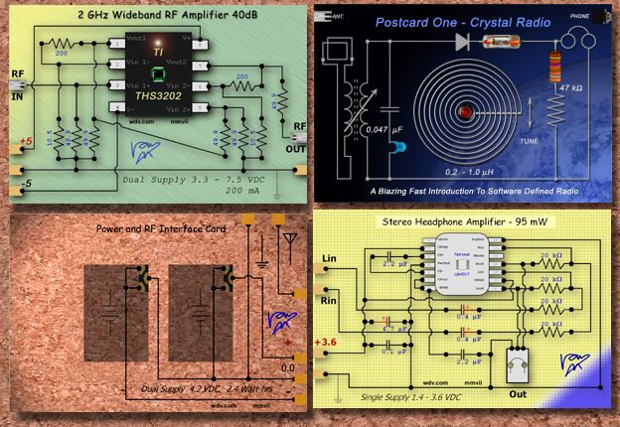

Figure 2: Mix and Match Postcards for Chapter 1

In the second chapter on amplifiers the crystal radio card is improved using an audio amplifier PostCardKit™, an RF amplifier PostCardKit™, and two kinds of power cards. One power card features rechargeable lithium batteries; the other uses solar cells for recharging and direct power. How green is that?! PostCardKits™ are flat, lead-free evaluation cards, printed on high quality paper with conductive ink. PostCardKits™ can be stamped and mailed, or mailed in envelopes to maintain pristine appearance. The first chapter is introduced with a crystal radio set. This card functions without any external or battery power. It receives AM radio stations. A first attemp on a file card pulled in stations from Asia and Central America.

You can hear fainter stations if you add an audio amplifier card. You can receive more stations if you add the RF amplifier. These additional cards require power. We will reuse the audio, RF amplifier and power cards in later chapters in novel ways. For example, the audio card is a stereo amplifier used for a special kind of station hunting called binaural radio.

Laterwe will develop radio software on a PC. Towards the end, we will extend the power of the hardware and software and reach for the stars.

The first PostCardKit™, Crystal Radio, utilizes a germanium diode for signal detection. It demonstrates the simplest effective combination of discrete components. It consists of an inductor, a capacitor, a resistor, a germanium diode detector and a piezoelectric crystal earphone.

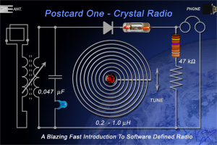
Figure 3: Crystal Radio PostCardKit™

Don’t let our simple start fool you; We will be moving many these functions into software and Software Defined Radio (SDR) can do sophisticated things.

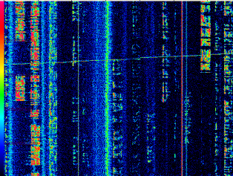
- RFSpace

Figure 4: Visualization of Radio Spectrum

The Crystal Radio PostCardKit™
The crystal radio is the simplest of all radios. In World War II, Allied GI’s used paper clips set against rusty razor blades to form crude diode junction receivers that the Nazi forces could not detect. These were dubbed “Foxhole receivers”. Crystal radios have a long and colorful history documented in Wikipedia and various radio collections documented on the web.

Attach the earphone provided to the jack in the upper left corner of the postcard. You probably won’t hear anything unless you live close to a powerful AM radio station. An antenna and a ground will improve your reach considerably. Just as a picture in the dark cannot be seen, a radio without an antenna cannot be heard. Lighting is half of art. The antenna is half of radio. You can learn more about antennas in the ARRL Antenna Book. It is highly recommended.

Putting Up the Litz
There is one errand to run before heading back to the easy chair. It is essential to route the Litz wire provided around a wall or ceiling to create an antenna. With antennas, bigger is usually better. I use a fold of masking tape to make a tiny hangar that holds the antenna on the wall. You can stick a clear pushpin through the tape to secure the antenna. Suspend the wire from the four corners of the room so it is up and out of the way. The wire provided is fine, so it is a quite aesthetic. When you are done, tin or sand the ends of the wire so that all the strands are conducting and install them in the connector provided. Now you have an antenna.

This square wire loop is a versatile omnidirectional antenna. If you wrap the antenna more than once around the room, the inductance will increase and the resonant frequency will drop according to:

Formula: Resonant Frequency

This formula informs us that those stations you manage to receive will be lower in the band, and lower in frequency. Start with one trip around the average sized room. Take your time getting this antenna right, it will serve you well. If you live on top of a hill, you will get better reception, but since radio waves bounce off the ionosphere, you will usually hear something unless you live in a salt mine. Using the clip provided, attach your antenna to the upper left hand corner your PostCardKit™ by the ANT. symbol. That was the hard part. You will also need a good ground. Grounding is discussed in an essential book on radio: The ARRL Radio Amateur’s Handbook.

Figure 5: Ideal Reception

Using the Crystal Radio
Now that the radio has a good antenna, you should be able to hear more stations. You can tune the radio with the knob in the center. Remarkably, it needs no power! You might want to keep a logbook of the signals you hear, the time of day along with any tweaks you have made to the radio or antenna. Low frequency signals travel better at night than in the daytime. Some high frequency signals are the opposite. Where do we look when an aircraft is lost? The radio logbook.

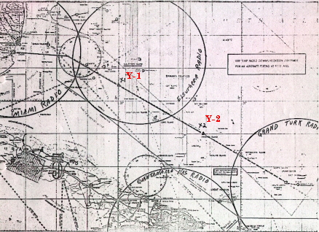

Figure 6 – Keeping a log enables discovery.

After you log a few entries it will be time to improve the radio. We will do that with the amplifiers mentioned above. Now for a little about how the crystal radio works.

Basic Parts
Picking up the card and shining the light on it you will notice it contains but five parts! The radio contains a diode, a resistor, an inductor, and two capacitors. Here is the schematic for the crystal radio including the Tidy TINA meter for RF power gain. The meter is used to optimize performance – it doesn’t appear in the final circuit.

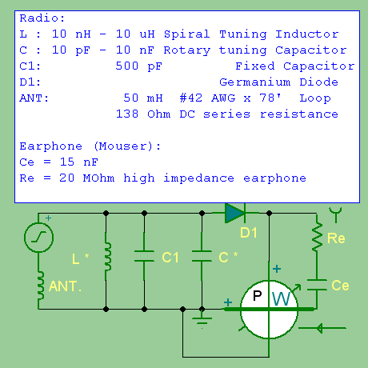

Example 0: Crystal Radio Schematic and Values

Just as in the Richter scale of earthquakes and the Fujitsu scale of tornadoes, we use a logarithmic scale when comparing the intensity of radio signals. This scale is measured in decibels (dB). This makes for much more reasonable comparisons. If two signals differ by a factor of two, they are about 3 dB apart. If they differ by a factor of four, they are 6 dB, and so on. Logarithmic scales turn multiplication into addition. This is useful when we want to talk about very large or small numbers. To convert a factor of 1000 to dB, you first count zeros to get 3. This corresponds to log(1000) = 3. Then you multiply by 10. 3 x 10 = 30 dB. So if two signals differ in power by a factor of 1000, then they are 30 dB apart:
In short dB = 10log(P), where P is power. Can you feel the power?

Tip - Use dB to compare the power of radio signals.

The resistor Re and capacitor Ce simulate the earphone. To really understand the crystal radio, we must understand the principles of the parts. If you are already an expert skip this quick review, but you might want to glance at the gain curves for voltage, current and power.
Resistors (units: Ohms) dissipate energy as heat. They impede the flow of electrical current, causing a voltage drop across the terminal ends. I once asked my dad if it wouldn’t be better if a circuit had no resistors at all because of this energy loss. He said “No” and then paused for a moment and said, “Yes”. The voltage drop E across a resistor is R times the current I, using Ohm’s law. You can think of an Ohm of resistance as the volt of force required to make an ampere of current flow.

Formula: Ohm’s Law

Power (Watts) is voltage times current. Is your resistor rated for the power passing through it? Touch it and see, but don’t get burned.

Formula: Power

With Ohms Law and Power, you can derive six others! Two other handy resistor formulas:

Add two resistors in series to obtain the equivalent resistance:

Formula: Series Equivalent Resistance

Use the product over sum for resistors in parallel:

Formula: Parallel Equivalent Resistance

The current flow in circuit loops and the voltage drop across circuit elements can be computed using Kirchoff’s Laws and Thevenin Equivalent circuits. The programming of these laws is already done for you in a tidy program called TINA-TI, a free download from the TI web site. I highly recommend it. Here is a classic voltage divider, simulated in TI’s TINA-SPICE

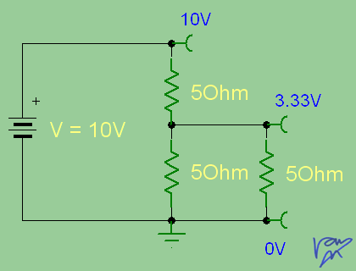

Circuit 1: Classic Voltage Divider Solved in Tidy TINA.

- Ordy

Figure 7: No room for color codes on surface mount resistors!
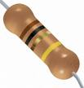

Notes on Resistors.
1) Always measure the value of a resistor before using it in a prototype circuit. Make sure your volt-ohm meter has a fresh battery.

2) In radio sections that operate at high frequencies we want resistors whose value does not vary with frequency. Thin-film and metal film resistors are preferred to wirewound resistors, which are really just lossy miniature inductors! Speaking of inductors…

Inductors (units: Henries)
store energy as a magnetic field. They are usually coils of wire or other conductive material in various shapes. Inductors have a direct current (DC) response and an alternating current (AC) response. These responses can be steady state or transient. Let’s throw the switch!

When the switch is closed on the circuit below, an equal and opposite voltage is “induced” in the inductor. This is induced voltage is called “back EMF”. After several time constants, the circuit reaches its “steady state”. The magnetic field is established and this opposing voltage disappears. If the switch is opened, the magnetic field collapses and sparks can ensue! There was an old saying, “nature abhors a vacuum”. Magnetic fields don’t like suddenly open switches. This is an important principle when working with sensitive semiconductor components. Fried!

To track voltage in Tidy TINA we add a pin connection . To track current we add an arrow connection seen at the bottom of the circuit. By convention positive current flows from positive to negative. Electron vacancies or “holes” move in this direction, but real electrons flow the other way. Thanks Ben Franklin!

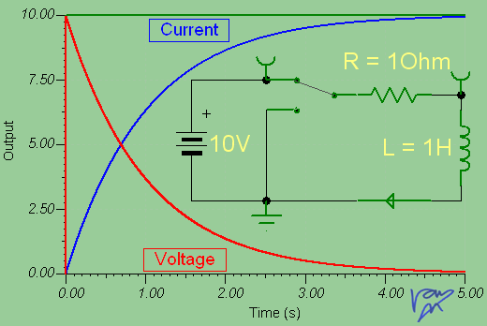

Circuit 2: Inductor Transient DC Response

Tidy TINA shows us two curves if we request a Transient Analysis. The top curve shows the current in the circuit. Since a coil is a conductor, keeping the switch on drains the battery. The bottom curve shows the induced voltage as it decays over time. This transient DC response ends with the steady-state DC response. What about AC, the stuff of which radio signals are made?

Consider the same circuit as before, but this time, we replace the DC battery with an AC signal generator and simplify the circuit to obtain:

The AC signal causes the inductor’s magnetic field to repeatedly collapse and expand in alternating directions. Ohm’s law is constantly running, but now there is a delay. This delay is caused by the union of magnetic field workers whose boss is Maxwell and whose contact is binding. Forget that. Remember this. Voltage E Leads Current I in an inductor.

.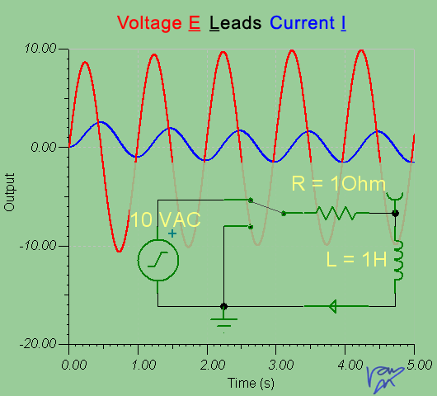

Circuit 3: Inductive AC Response

ELI the ICE man reminds us that voltage leads current by 90° in an inductor. This is called phase shift. Radio is all about keeping track of phase. We draw voltage in red and current in blue on the same graph so we can see their relationship in time. But what about frequency?

Frequency Response: What Happens When Inductance and Resistance Change?
Now we can play with the inductor and resistor values and see what happens in our circuit. We will measure this by comparing the gain of various configurations. Gain is the amplitude of the signal in a circuit. Gain comes in three flavors, voltage gain, current gain and power gain. Power gain is voltage gain times current gain. We want to know how the gain changes as we change the frequency of our input signal. We can determine this quickly with Tidy TINA. First, we fix the resistor at 1 Ohms and set the inductor to 1 microHenries. Then we ask TINA to compute the AC Transfer Characteristics. Voila! We get a graph that yields major insight.

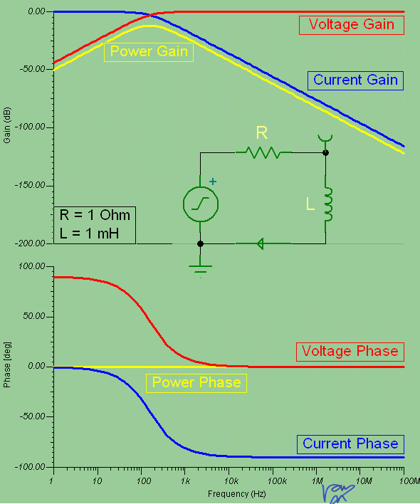

Circuit 4: One milliHenry Inductor Frequency Response

Next we want to know what happens if the inductance changes, say, to a thousandth of its value. That would be 1 microHenry (uH). Again, TINA computes the AC transfer characteristic, sweeping the frequency from 1 to 100 MegaHertz. This feels more like radio! Out pops our next graph. Decreasing the inductance has shifted all our gain curves to higher frequencies.

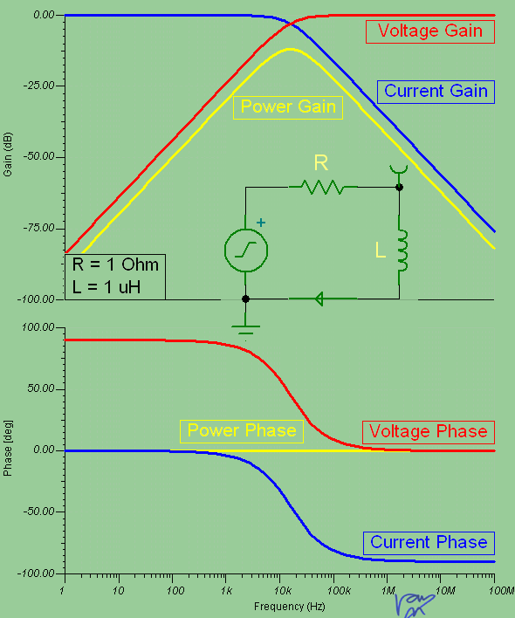

Circuit 5: One microHenry Inductor Frequency Response

Now we can run different cases for hours, and trust me, I have. The trick is to focus on essential relationships. What happens if we change the resistor value but not the inductor?

Let’s return the inductor to 1 milliHenry and change the resistance from 1 to 100 Ohms. What happens? How does increased input resistance affect frequency response?

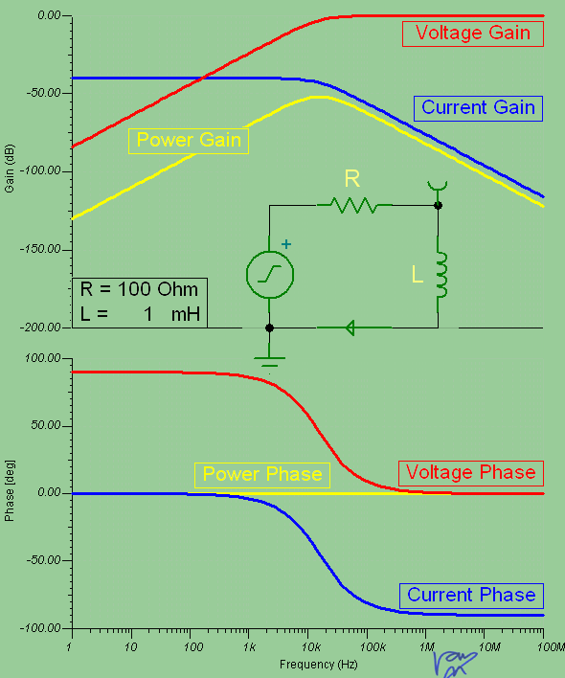

Circuit 6: Inductive Frequency Response – Increased Series Resistance

If we compare Circuit 4 and Circuit 6, there is a loss in current gain as a direct consequence of the resistor. That makes sense. So to first order, we observe that with respect to voltage we have a high pass filter – so named because high frequencies are passed and low frequencies are blocked. With respect to current, we have a low-pass filter, and with respect to power, we have a band-pass filter. Interesting, no?

Inductor Calculations

Inductors are like resistors when it comes to equivalent circuits.

Adding two inductors in series gives the equivalent inductance of the pair:

Formula: Series Equivalent Inductance

Use the product over sum for inductors in parallel:

Formula: Parallel Equivalent Inductance

Transformers are inductors that are magnetically coupled by their proximity to each other. We will discuss them in more detail later.

Inductors have a kind of imaginary AC resistance called inductive reactance that has units of Ohms.

Formula: Inductive Reactance

Inductive circuits have a time constant that we alluded to above. This is the time it takes for the current to build up to 63.2% of its steady state value. The units are seconds.

Formula: Inductive Time Constant

By choosing the right value of inductors, we can tailor the frequencies we block or pass using “analog filtering”. More on that and its upscale digital cousin in a moment. Take a break. Don’t become incapacitated!

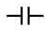Capacitors (Farads)

store energy as an electric field. They consist of plates of foil separated by an insulating or dielectric material. Like their inductive counterparts, capacitors have a direct current (DC) response and an alternating current (AC) response.

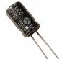
When the switch is closed, there is a surge of current until charge accumulates on the plates of the capacitor. After several time constants, the circuit reaches “steady state”. The electric field is established and the current surge disappears. If the switch is opened, nothing happens but the capacitor remains fully charged! A large capacitor can shock you!

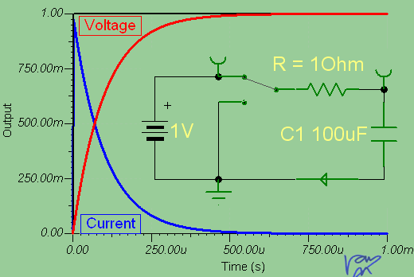

Circuit 7: Capacitor Voltage and Current Vs. Time, Transient DC Response

This simulation uses a 1-Farad capacitor, which is physically large, about the size of a large soup can. In radio, we typically work with much smaller values as we shall soon see. The principles and response curves are similar; the time constants are much shorter. Remember these units and abbreviations; you will use them often, especially nano and pico.

Unit | Abbrev. | “Of a Farad” | Multiplier | Comment
Farad | F | 1 | 1 | Huge!
milliFarad | mF | 1 thousandth | 10⁻³ | Big!
microFarad | µF | 1 millionth | 10⁻⁶ | Pwr. Sup.
nanoFarad | nF | 1 billionth | 10⁻⁹ | Various
picoFarad | pF | 1 trillionth | 10⁻¹² | RF freq.

Table 1: Unit Prefixes, Abbreviations and Multipliers

Consider the same circuit as above, but we replace the DC battery with an AC signal generator like so.

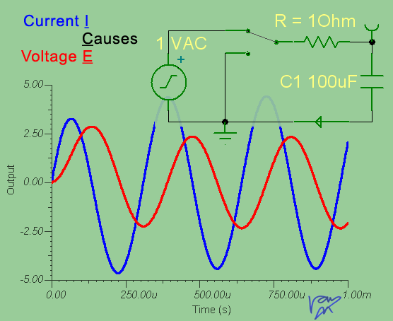

Circuit 8: Capacitive AC Response

The AC signal causes the capacitor’s electric field to repeatedly collapse and expand in alternating directions. Ohm’s law is constantly running, and again there is a phase delay. Current Causes Voltage in a capacitor. The word “Causes” is just a hack so that we remember the C for Capacitor in the famous ELI-the-ICE-man phrase that reminds us that voltage leads current in inductors and current leads voltage in capacitors.

Frequency Response: What Happens When Capacitance and Resistance Change?
Just like before we play with capacitance and resistor values to see what happens in our circuit. Again, we will measure this by comparing the gain of various configurations. First, we fix the resistor at 1 Ohms and set the capacitor to 100 uF. Then we ask TINA to compute the AC Transfer Characteristic. A graph again provides insight:

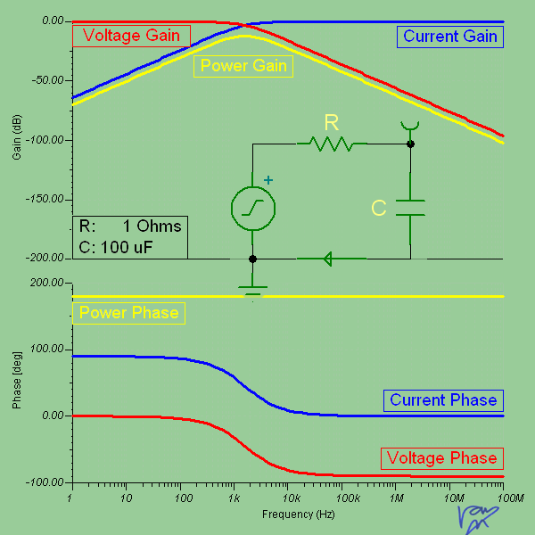

Circuit 9: 100 uF Capacitor Frequency Response

As before we want to know what happens if the capacitance changes, this time to a hundredth of its value. We set the capacitor to 1 uF (1 microFarad). Again, TINA computes the AC transfer characteristic, sweeping the frequency from 1 to 100 MegaHertz. That radio feeling is coming on strong.

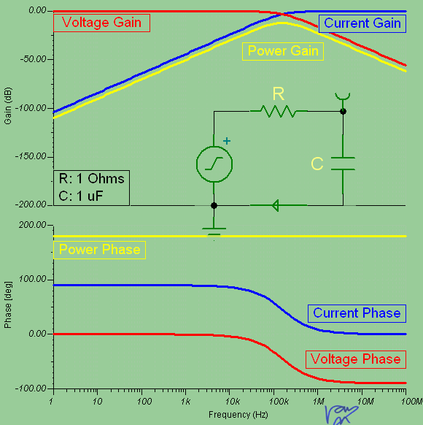

Circuit 10: 1 uF Capacitor Frequency Response

Are you starting to see a pattern? What happens if we change the value of the resistor but not the capacitor? Let’s return the capacitor to 100 uF and change the resistance from 1 to 100 Ohms. What happens? How does increased series resistance affect circuit frequency response?

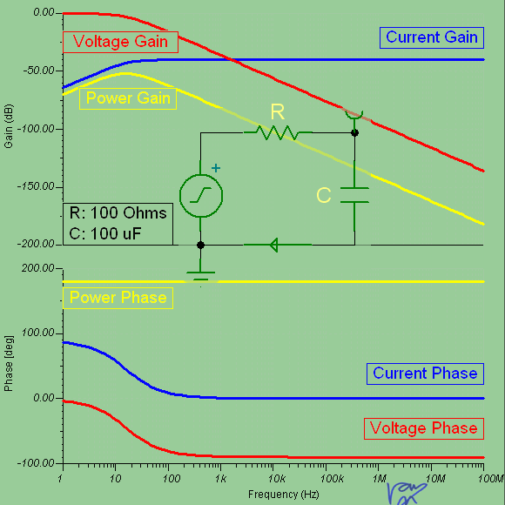

Circuit 11: Capacitive Frequency Response – Increased Series Resistance

If we compare Circuit 9 and Circuit 11, there are two effects of keeping the same capacitor and increasing the resistance. Current gain decreases. That makes sense. The second effect is to shift the curves to the left. It looks like we increased the capacitance, but we didn’t.
We observe that our capacitor drains more slowly when the resistance is higher. In an opposite sense to inductors, capacitors are a low-pass filter with respect to voltage and a high-pass filter with respect to current. With respect to power, we have a band-pass filter as before.

Capacitor Calculations
Capacitors are the opposite of inductors and resistors when it comes to equivalent circuits.

Because it looks like increasing plate area, adding two capacitor values gives the PARALLEL equivalent capacitance:

Formula: Parallel Equivalent Capacitance

Use the product over sum for capacitors in SERIES:

Formula: Parallel Equivalent Inductance

There isn’t the capacitive equivalent of a transformer.

Capacitive circuits have a time constant. This is the time it takes for the voltage to build up to 63.2% of its steady state value. The units are seconds.

Formula: Capacitive Time Constant

Capacitors also have a kind of imaginary AC resistance called capacitive reactance that has units of Ohms.

Formula: Capacitive Reactance

That’s it for capacitance right now. Consult the references in the last chapter if you want to delve in deeper than time allows here.

Summary – Capacitance and Inductance:
The figure below summarizes what we have just discovered by direct simulation. Inductors and Capacitors are the inverses of each other. This is an idea as deep as the electron itself.The left column shows a capacitive circuit and the right column shows its inductive counterpart. The component values are summarized in the lower left corner of each diagram. As before voltage gain is red, current gain is blue, and power gain is yellow.

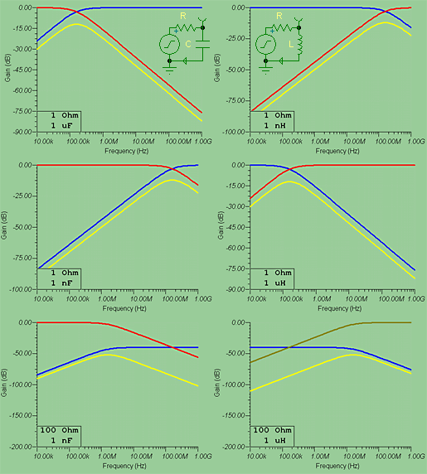

Figure 8: Side-By-Side Comparison - Capacitance and Inductance

RLC Behavior – Parallel Case
Consider an RLC circuit where the inductor and capacitor are in parallel. The following figures catalog voltage, current and power gain as we vary component values. You can reproduce these results in Tidy TINA and see which values result in which curves, a worthwhile bit of fun. The flat line in each image is the gain for the source, set to 1 milliVolt to simulate a strong radio station.

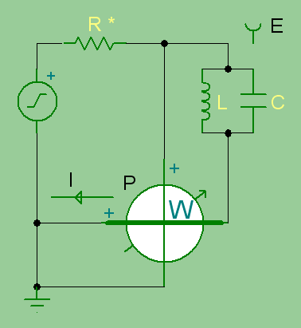

Circuit 12: RLC Circuit – Parallel LC

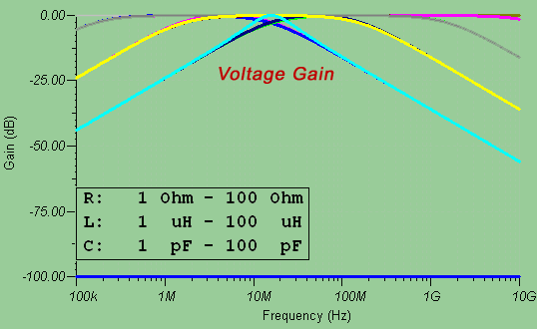

Figure 9: RLC Circuit – Parallel LC – Voltage Gain

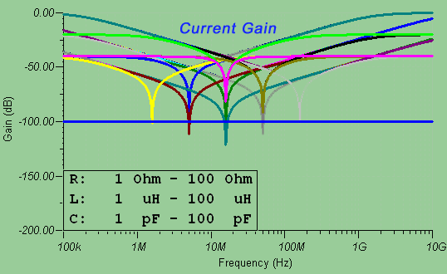

Figure 10: RLC Circuit – Parallel LC – Current Gain

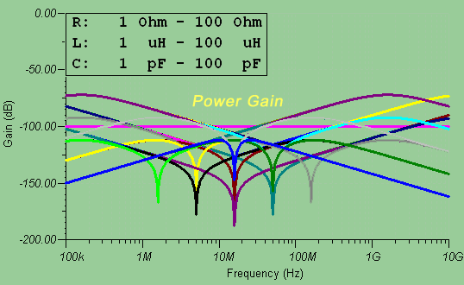

Figure 11: RLC Circuit – Parallel LC – Power Gain

RLC Behavior – Series Case
Consider an RLC circuit where the inductor and capacitor are in series. Note the difference in the response curves in series versus parallel components. You can right click a specific curve in Tidy TINA to discover the RLC values that gave rise to it. One thing you will notice is that while the parallel case is a band-stop filter for RF power, the series case is a band-pass in most cases. The peakiness of the filter is the Q or Quality Factor of the resonant circuit. More on that later. Notice that series resistance hurts performance of the band-pass filter, turning it into a band-stop filter! Not good for tuning in your favorite crystal radio station. Again, we set the source to 1 mV to simulate a strong station. We will make those conditions more severe later.

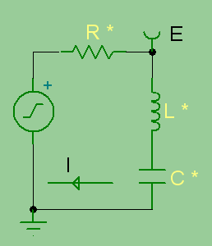

Circuit 13: RLC Circuit – Series LC

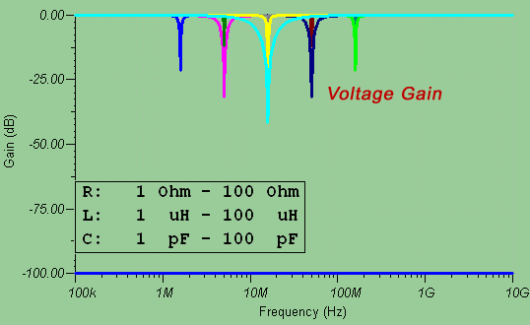

Figure 12: RLC Circuit – Series LC – Voltage Gain

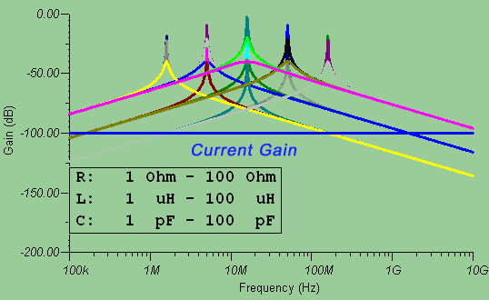

Figure 13: RLC Circuit – Series LC – Current Gain

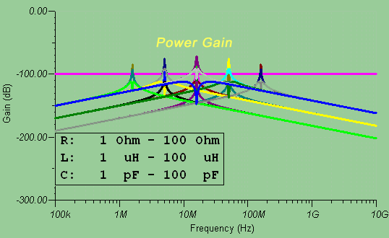

Figure 14: RLC Circuit – Series LC – Power Gain

Diodes
do not store energy like capacitors and inductors. They are one-way valves for the flow of current. They are arguably the most important single component in radio because of the multiple purposes they serve. Diodes are semiconductors consisting of a P-N junction doped to attain desireable characteristics. Like their siblings, diodes have a direct current (DC) response and an alternating current (AC) response. These responses can be steady state or transient. Let’s throw the switch!

Notice that the circuit below uses two single pole double throw switches connected so that we can switch the polarity on the diode. We retain the series resistor as a current-limiting resistor, although in a real circuit, say with a light-emitting diode, the value would be considerably higher, between 500 and 2000 Ohms to prevent the diode from burning out.

In this simulation we assume the diode can take whatever the flow of current is and we observe the transient DC response for two cases. The first case when both switches are down, corresponds to the normal polarity of DC voltage seen in previous examples. The diode is positioned so that this is a forward voltage corresponding to the direction in which the diode allows current to flow. The current curve is blue and the forward voltage curve is red. Notice that the diode takes only a few picoseconds for the diode to switch on. The time it takes a diode to turn on is an imporant parameter of the diode, especially for radio work.

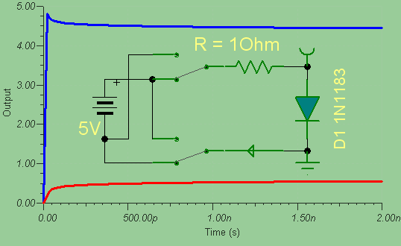

Circuit 14: Diode Transient DC Response – Forward Current

Now let’s reverse the position of both switches to simulate flipping a double pole double throw (DPDT) switch. This reverses the polarity of the battery. What do think the curves will look like?

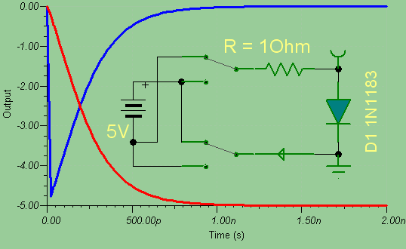

Circuit 14: Diode Transient DC Response – Reverse Current

This case shows the diode in the direction it does not want to conduct. There is a momentary surge of current until the diode turns off. Note that it takes this diode longer to turn off than it does to turn on – in the simulation at least. About a nanosecond. Do these curves remind you of anything familiar?

Now let’s replace the DC battery with an AC signal generator and simplify the circuit to. We don’t need the DPDT switch, because the AC signal generator is doing that for us. The simplified circuit looks like this:

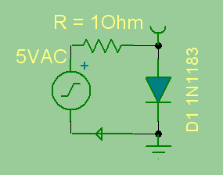

Circuit 15: Diode AC Circuit

Let’s run the signal generator at a low frequency, say 60 Hz. This is the frequently encountered in power supplies running from wall current in the US after a step-down transformer. We obtain the expected and classic waveform for half-wave rectification of an AC signal.

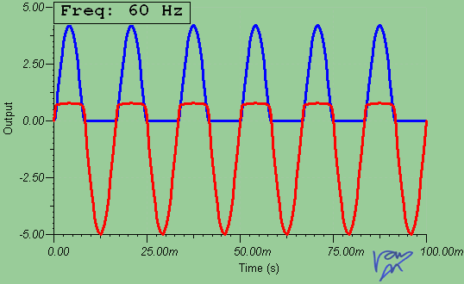

Figure 15: Diode 60 Hz Frequency Response

Now let’s run the frequency up to the high end of the audio sampling spectrum, say 44 kHz. Notice that we start encountering some switching noise as we approach the switching speed of the diode.

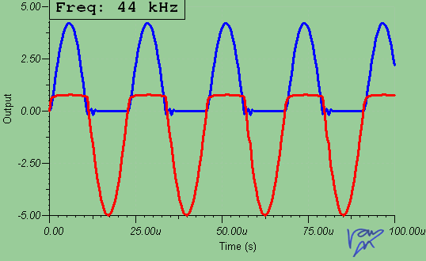

Figure 16: Diode 44 kHz Frequency Response

Finally let’s run the diode at a frequency we might encounter in our crystal radio, say the middle of the AM band:

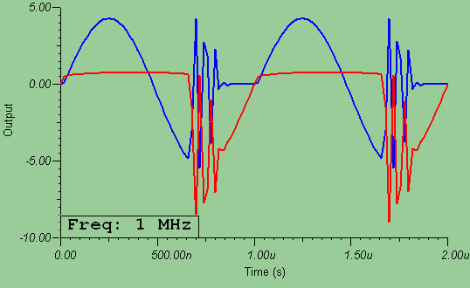

Figure 17: 1N1183 Diode 1 MHz Frequency Response

Now our signal is dominated by switching noise. This particular diode, can’t switch fast enough to rectify the signal. Notice the ringing. The only way to see it is to integrate using the Gear method with a 6th order integration. Changing the diode to a faster 1N4150 largely eliminates the ringing.

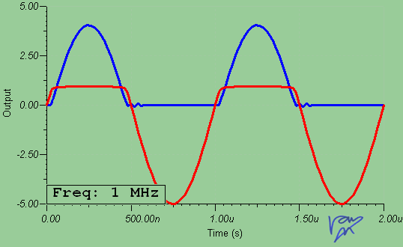

Figure 18: 1N4150 Diode 1 MHz Frequency Response

Diode Calculations

For low frequency applications diodes can be stacked in series.

Connecting two diodes in series doubles the peak reverse voltage (PRV) rating:

Formula: Series Equivalent Inductance

Connecting two diodes in parallel doubles the current rating:

Formula: Series Equivalent Inductance

It the first case it is necessary connect a high value resistor across eacg diode to minimize transients and equalize slight differences in the characteristics of the diode. One rule of thumb is to multiply the PRV of the diode by 400. In the second a low-value resistor, usually less than an ohm, is connected in series with the pair of diodes.

Summary

This concludes chapter one. We have seen a simple radio, a crystal radio, and how each of the parts work. Now we will look in detail at fundamentals of software defined radio, including software and hardware.

Acknowledgements

For any of the things in this rapid introduction that work for teaching and understanding SDR I would like to express my sincere thanks to:

Brian Beckman
Prof. John Beem
Rick Campbell – KK7B
Ken Copeland – K5KD
Pat Kane
Marilyn Fulper
Greg Ordy – W8WWV – seedsolutions.com
Joe Stone
Russ Sandberg
Tom Stockham
John Waller
David Warren
Lynn Warren
Nick Warren

TI-TINA SPICE

http://www.wpclipart.com/signs_symbol/electrical/ for free use of clip-art component icons

http://ezinearticles.com/?Easy-Method-To-Connect-Diodes-In-Series-And-Parallel-To-Get-The-Desire-Specification&id=502120 for diode calculations

Index

AC Transfer Characteristic, 19
AM band, 31
analog filtering, 16
antenna, 5, 6, 7
ARRL Antenna Book, 5
band-pass filter, 15, 21, 26
battery, 4, 10, 11, 12, 18, 28, 29
Ben Franklin, 11
binaural radio, 4
capacitor, 5, 8, 17, 18, 19, 20, 21, 22, 24, 26
Capacitor Frequency Response, 19
crystal radio, 4, 5, 7, 8, 26, 31, 32
current, 8, 9, 11, 12, 13, 15, 16, 17, 18, 21, 23, 24, 28, 29, 30, 32
dielectric, 17
diode, 5, 7, 28, 29, 30, 31, 32, 34
DSP, a
earphone, 8
electric field, 17, 18
Foxhole receivers, 5
frequency, 6, 7, 10, 12, 13, 14, 15, 20, 30, 31, 32
Gear method, 31
germanium diode, 5
high pass filter, 15
inductance, 6, 14, 16
Inductive Reactance, 16
inductor, 5, 7, 11, 12, 13, 14, 15, 24, 26
Inductors, 11, 16, 23
ionosphere, 6
Jimi Hendrix, 3
Kirchoff’s Laws, 9
Litz, 6
logbook, 7
low-pass filter, 15, 21
magnetic field, 11, 12
nano, 17
Ohm’s law, 9, 12, 18
omnidirectional antenna, 6
Parallel Equivalent Inductance, 16, 22
Parallel Equivalent Resistance, 9
pico, 17
polarity, 28
PostCardKits™, 4
PostCardKit™, 4, 5, 6
power, 4, 7, 8, 9, 13, 15, 21, 23, 24, 26, 30
Power, 9, 13, 25, 27
product over sum, 9, 16, 22
Q, 26
Quality Factor, 26
rectification, 30
resistance, 9, 15, 16, 20, 21, 22, 26
resistor, 5, 7, 8, 9, 10, 13, 14, 15, 19, 20, 28, 32
Resonant Frequency, 6
samples, 5
Series Equivalent Inductance, 16, 32
Series Equivalent Resistance, 9
series resistance, 20
signal generator, 18
simulation, 3
Software Defined Radio, 3
switching noise, 30
Thevenin Equivalent, 9
TINA, 7, 9, 10, 11, 13, 14, 19, 20, 24, 26, 34
Transient Analysis, 11
Transient DC Response, 11, 17, 28, 29
voltage, 8, 9, 11, 12, 13, 15, 18, 21, 23, 24, 28, 32
Voltage Divider, 10
wirewound resistors, 10

